**Lease Management**

# 1. Project Overview

This project is focused on [The Lease Management ]project aims to develop an efficient system within Salesforce for managing lease processes related to real estate properties, equipment, or other assets. The objective is to streamline and automate tasks such as lease creation, tracking, and renewals while ensuring compliance with regulatory requirements. This centralized platform will enhance operational efficiency, improve tenant satisfaction, and provide accurate record-keeping and timely notifications to all stakeholders. The system will also support the organization’s strategic goals by providing actionable insights and enabling better communication between landlords, tenants, and property managers.

# 2. Objectives

The primary objective of this project is to simplify and automate the lease lifecycle, reducing manual effort and minimizing errors. The system will improve data accuracy, ensure compliance, and facilitate collaboration across departments. Specific outcomes include creating a Salesforce-based lease management system, automating workflows such as renewal notifications, integrating with external systems for payment processing, and providing detailed dashboards to track key metrics like occupancy rates and revenue. By achieving these objectives, the project will support better decision-making and enhance the overall user experience for all stakeholders involved.

**Business Goals**

* Automate and simplify lease lifecycle management.
* Reduce manual effort and human errors in lease processes.
* Provide timely reminders for lease-related tasks (e.g., renewals, payments).
* Improve tenant satisfaction through transparent communication.

**Specific Outcomes**

* Deployment of a lease management system using Salesforce.
* Integration with accounting tools for payment processing and tracking.
* Custom workflows for lease renewal notifications.
* Dashboards for monitoring key performance indicators (KPIs) such as occupancy rates and revenue forecasts.

**3. Salesforce Key Features and Concepts Utilized**

# This lease management solution leverages Salesforce features to deliver a comprehensive system. It allows for the creation and management of lease agreements, tenant profiles, and property records through interconnected custom objects such as Lease Agreements, Tenants, Properties, and Payments. The system automates critical workflows, such as sending reminders for lease renewals and overdue payments. It includes validation rules to enforce data accuracy, like preventing overlapping leases on the same property, and integrates with external systems like QuickBooks for financial reporting and DocuSign for secure lease document management. Custom dashboards and reports offer real-time insights into lease performance, enabling property managers to track metrics such as revenue forecasts, payment schedules, and occupancy rates effectively.

# 4. Detailed Steps to Solution Design

The solution design involves a robust data model that incorporates custom objects and relationships to support lease lifecycle management. Key objects include Lease Agreements, which store details such as start and end dates, monthly rent, and payment due dates, linked to Tenants and Properties through lookup relationships. Validation rules and Apex triggers are implemented to maintain data integrity and automate status updates for leases, such as marking them as “Expired” when their end date passes. Automated workflows send timely notifications for lease renewals and payment reminders. Custom Lightning pages are designed to provide users with an intuitive interface for managing leases, properties, and tenants. These pages include consolidated views of related data, ensuring that all critical information is accessible in on e place.

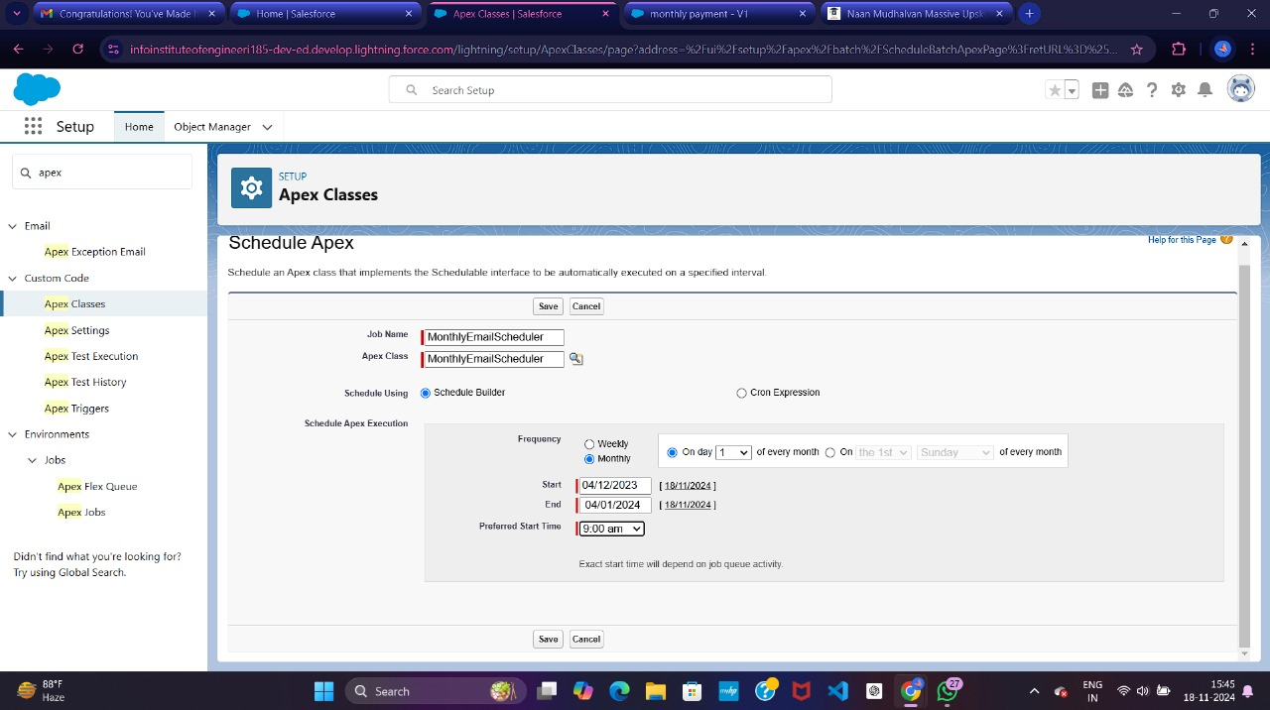

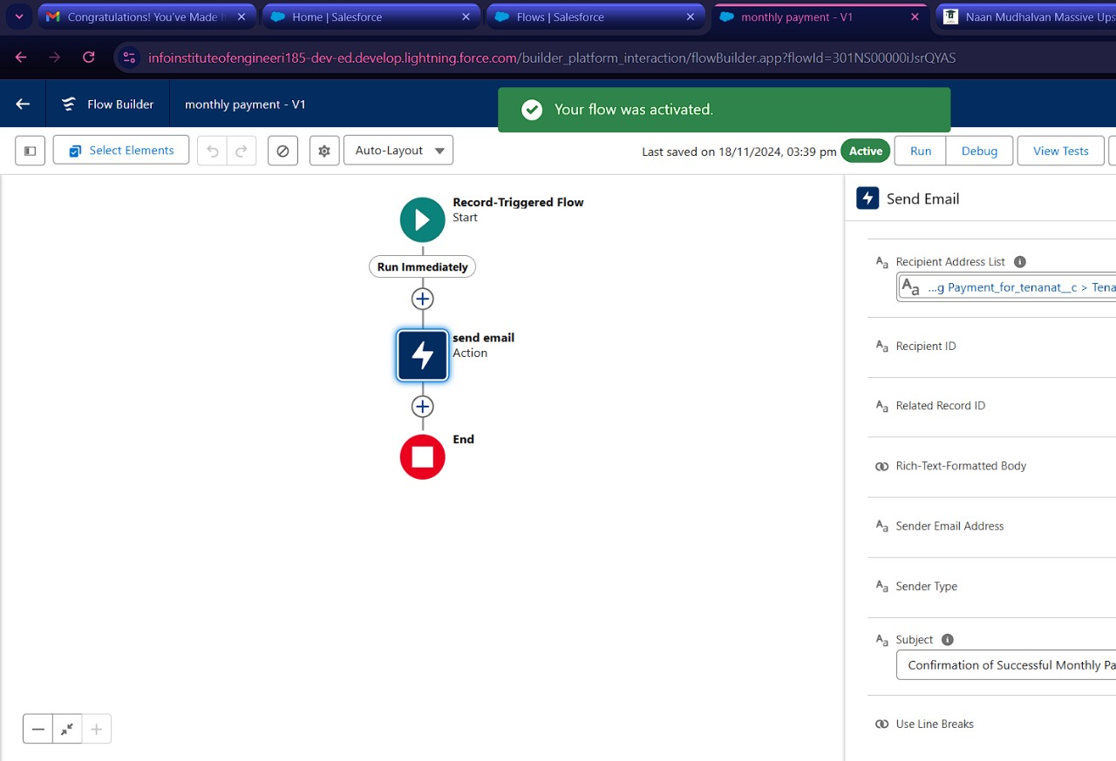

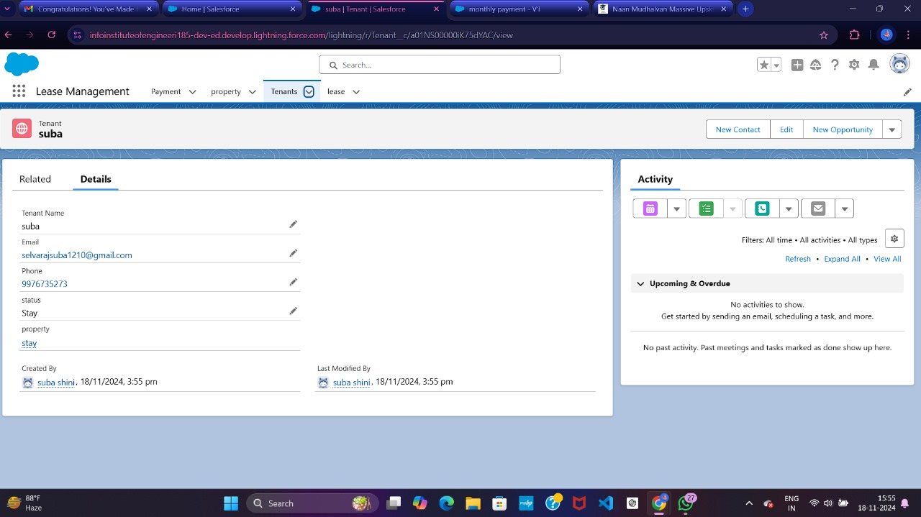

# 5. Testing and Validation

* Unit Testing:

1. Apex test classes to validate triggers and automation rules.
2. Test scenarios:
3. Lease creation and validation.
4. Notifications for expirations and overdue payments.

* System Testing:

1. Verify workflows and integrations (e.g., accounting tools).
2. Ensure accurate data flows between objects (e.g., Tenant → Lease → Property).

* User Acceptance Testing (UAT):

1. Allow end-users to test real-world scenarios for lease creation, payment tracking, and notifications.

## 6. Key Scenarios Addressed by Salesforce in the Implementation Project

 The system addresses multiple scenarios critical to effective lease management. It simplifies the lease lifecycle by automating tasks such as lease expiration notifications and payment tracking. The solution prevents data errors through validation rules that enforce business logic, such as ensuring properties cannot be leased to multiple tenants simultaneously. Additionally, it supports occupancy management by providing real-time insights into property availability. Custom workflows and dashboards enable users to manage payments efficiently, track overdue accounts, and forecast revenue. These features collectively ensure a smooth and efficient lease management process while addressing various operational challenges.prevents data errors through validation rules that enforce business logic, such as ensuring properties cannot be leased to multiple tenants simultaneously. Additionally, it supports occupancy management by providing real-time insights into property availability. Custom workflows and dashboards enable users to manage payments efficiently, track overdue accounts, and forecast revenue. These features collectively ensure a smooth and efficient lease management process while addressing various operational challenges.



# 7. Conclusion

The Lease Management project successfully delivers a robust Salesforce-based system that addresses key challenges in managing lease agreements. It automates manual tasks, reduces errors, and ensures compliance with industry regulations, resulting in a more efficient and reliable process. The solution provides actionable insights through dashboards and reports, enabling better decision-making and improving tenant satisfaction. With its integration capabilities and streamlined workflows, the system supports the organization’s strategic goals and positions it for long-term success in lease management.